**A000-**Eur-Czech Rep-Venus from Ostrava-Petřkovice, Silesia-Hematite-23,000 [BCE](http://en.wikipedia.org/wiki/Common_Era) ([Gravettian](http://en.wikipedia.org/wiki/Gravettian) [Industry](http://en.wikipedia.org/wiki/Archaeological_industry))

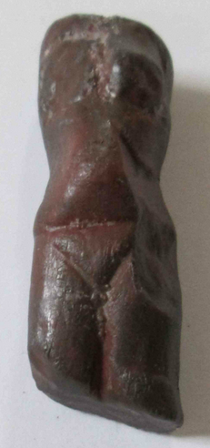 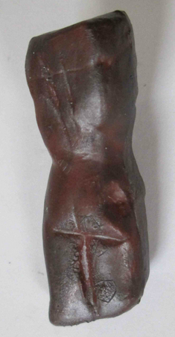

Figs. 1-2. Czech Rep-Venus from Ostrava-Petřkovice, Silesia-Hematite-23,000 [BCE](http://en.wikipedia.org/wiki/Common_Era) ([Gravettian](http://en.wikipedia.org/wiki/Gravettian) [Industry](http://en.wikipedia.org/wiki/Archaeological_industry))

**Case no.: 1**

**Accession Number: A000**

**Formal Label:** Eur-Czech Rep-Venus from Ostrava-Petřkovice, Silesia-Hematite-23,000 [BCE](http://en.wikipedia.org/wiki/Common_Era) ([Gravettian](http://en.wikipedia.org/wiki/Gravettian) [Industry](http://en.wikipedia.org/wiki/Archaeological_industry))

**Display Description:** *Petřkovická venuše* or *Landecká venuše.* Venus from Ostrava-Petřkovice. It was found by archaeologist Bohuslav Klima on 14 July 1953 beneath a mammoth molar. It is a headless torso of a body of a woman carved from iron ore (hematite). The absence of the head appears to be the artist’s intention. Unlike other prehistoric Venus figurines, it shows a slender young woman or girl with small breasts.

**LC Classification:**  [GN772.22.C94](http://libcat1.amnh.org/search?/cGN772.22.C94+P48+2008/cgn++772.22+c94+p48+2008/-3,-1,,E/browse)

**Date or Time Horizon:** 23,000 [BCE](http://en.wikipedia.org/wiki/Common_Era)

**Geographical Area:** Ostrava-Petřkovice, Silesia, Czech Republic.

**Map:**

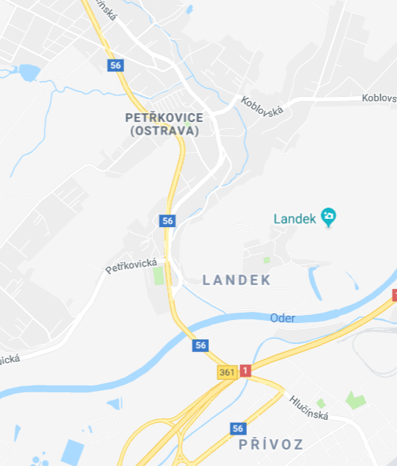

Fig. 3. Map ofOstrava-Petřkovice, Silesiafrom https://www.google.com/maps/@49.8707257,18.2429779,14z

**GPS coordinates:** 49º52'29.04" N 18º15'19.11" E

**Cultural Affiliation:** Paleolithic Venus of Silesia, the Czech Republic.

**Medium:** Hematite

**Dimensions:** 45 x 15 x 13 mm.

**Weight: n/a**

**Condition: replica in resin**

**Provenance:** (Ostrava-Petřkovice), Silesia, the Czech Republic. It is now in the Archeological Institute, Brno.

**Discussion:**

This hematite female figurine was carved deliberately without head or limbs. However, it is carved to show a slim hour glass figure with a slightly prominent stomach. The breasts are diminutive and the incised pubic triangle is demonstrably large.

**References:**

Freeman, Leslie G., ed. 2011. *Views of the Past: Essays in Old World Prehistory and Paleanthropology*. Berlin: De Gruyter Mouton Publishers.

Klíama, Bohuslav. 1956. “Coal in the Ice Age: The Excavation of a Palaeolithic Settlement at Ostrava-Petřkovice in Silesia,” *Antiquity*, 30(118): 98-101.